

Unilever – People Voice

Functional Specification

# Confidential Information

This document is submitted under strict commercial confidentiality and no part of it may be disclosed for any reason to any third party without prior written consent from authorised representatives of Golin.

# Document History

|  |  |  |
| --- | --- | --- |
| Date | Author | Comments |
| 24/5/17 | Peter Kemp | As per client request, updating the document to reflect the change in requirements whereby the News Article pages are hosted internally within the People Voice site, rather than in the News Centre. |
| 24/5/17 | Davide Ranchetti |  |

# Reviewers

|  |  |  |
| --- | --- | --- |
| Date | Name | Position |
| 25/5/17 | Rosalind Harber | Digital Project Manager |
| 24/5/17 | Peter Kemp | SharePoint Director |

Table of Contents

Confidential Information 2

Document History 2

Reviewers 2

1 Overview 5

2 Business requirements 5

3 Wireframes 5

4 User Interface Design 5

5 Common Components 6

6 Pages 7

6.1 Home 7

6.2 Category page 10

6.3 All Articles 11

6.4 News Article 13

7 Information Architecture 14

7.1 Site 14

7.2 Lists 14

7.3 Libraries 15

7.4 Content Types 15

7.5 Site Columns 16

8 Solution Assets 17

8.1 Master pages 18

8.2 Page layouts 18

8.3 CSS 18

8.4 JavaScript 18

8.5 Frameworks and Libraries 19

8.6 Imagery 19

8.6.1 Image renditions 20

8.7 Fonts 20

9 Accessibility 20

10 Development 21

10.1 Code Control 21

11 Browser & Device Testing 21

12 Deployment 22

13 Training 22

14 Documentation 23

# Overview

The following document provides detailed functional and technical specifications for the development of the Unilever People Voice site. The site will be built on SharePoint on Unilever’s Inside.Unilever Microsoft Office 365 tenancy.

The specifications and information in this document are limited to the technical implementation of the People Voice site and assume administrative knowledge of SharePoint Online and Office 365.

# Business requirements

The primary aim of the platform is to provide an engaging news site. Based on internal and external sources, with themes related to People Understanding, the site will support five new articles every week. Articles should be able to support rich text, imagery and embedded video content. Optimised for both mobile and desktop access, the site should have a journalistic feel, which is dynamic and interactive.

# Wireframes

Following a number of high level requirements gathering calls and meetings focused on ascertaining the correct user experience for the People Voice site, Golin produced a series of Axure wireframe prototypes. The aim of these wireframes is to depict the intended structure and functionality of the site. These mock-ups are available at the following URL:

<http://ux.architectclients.com/unilever/people-voice/wireframes/#g=1>

# User Interface Design

During the design phase Golin brought the agreed structure and wireframes to life by creating design mock-ups. Where designs are available they have been featured in this document. The design mock-ups are available here:

<https://invis.io/5CBTEYJK8>

# Common Components

In SharePoint, the common page components are held in a master page, a feature that enables the definition of a common structure and interface for the site, including headers, footers, style definitions, navigation bars etc. The master page will be shared by all of the publishing pages of the site and removes the need to duplicate shared elements.

**NOTE** The People Voice site will use the Inside Unilever master page. Golin will make no changes to the master page as part of this project.

Below is a mock-up of the overall master page and common components of the site:

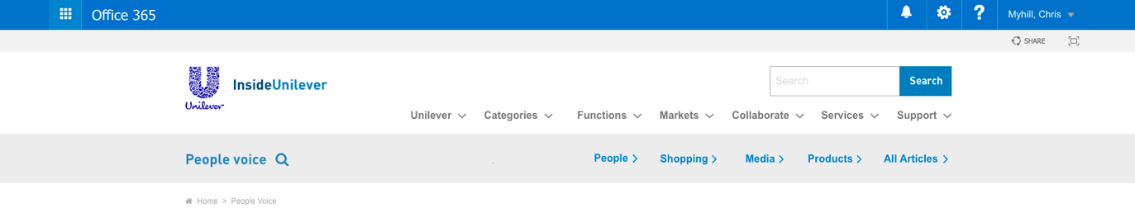



The numbered common components are outlined below:

1. **Suite Bar.** The code used to generate the SharePoint out-of-the-box suite bar is duplicated directly from SharePoint’s own seattle.master file, with no modifications.
2. **Logo.** The logo, which is situated at the top of every page in the site’s header, uses the out-of-the-box SharePoint SiteLogoImage control, with the link returning users to the Home page of the site.
3. **Search.** A text field that allows users to input keyword search terms. When the magnifying glass icon is clicked or the user hits return, they are redirected to the Directory page where the results are filtered and sorted by the inputted search term.
4. **Global Navigation.** Inherited from the Inside Unilever intranet, this area holds a series of links that provide access to the separate sections of the wider Inside Unilever intranet site.
5. **Title.** This is pulled from the SharePoint site title.
6. **Contextual Navigation.** This area displays the navigation items managed from within that particular site collection. Permissioned administrators are able add and manage both parent and child navigation links from the SharePoint out-of-the-box navigation feature. Five parent links will be added to the contextual navigation to provide access to the Category pages (People, Shopping, Media and Products) and the All Articles page.
7. **Footer Links.** This area holds a number of links which are available to the user on every page.
8. **Social media buttons.** A collection of social media buttons and a link button to the Unilever website (<https://www.unilever.co.uk/>).

# Pages

The following section outlines the main pages/views created as part of the People Voice site and the features and functionality of each.

## Home

The home page is the primary entry point for most users of the the People Voice site and presents the most recent and ‘trending’ People Voice articles. The page also provides access to other People Voice information such as relevant sites and wider Unilever news and events.

The page, which is set as the home page of the site, will be created from a single publishing page and use a series of Content Editor Web Parts to render HTML templates that drive the page content.

The following annotated image shows the design for this page:



The numbered components are outlined below:

1. **Header.** An area that displays the logo, title and a brief description of the People Voice site. This is presented on each page and held in the page layout files.
2. **Consumer Index.** An area that displays the consumer index for a set of regions in a carousel. This information is driven and managed in the *Consumer Index* list. From the list administrators can add items with a country, index and a rating (green, amber and red)
3. **News Articles.** A series of news articles pages that are created from the People Voice content type which are held in the Pages library of the People Voice site. Each news tile displays a rollup image (a default image will be added if none is provided), a title, a brief description, the associated category (which when clicked directs the user to the relevant category page) and a link button to access the article page itself. If the article has been tagged as a Spotlight article, then a label and icon appear in the top left of the tile and the title of the article is presented in pink.
   1. **Recent Spotlight.** This area displays the most recent news article that has been tagged as a Spotlight article.
   2. **Recent News.** A listing of the four most recently published articles.
   3. **Trending.** A list of the four most viewed articles in the People Voice site, excluding the recent Spotlight article and the four more recently articles to avoid duplication of the same article on the home page. The trending articles will be retrieved using the Search APIs, to access the OOTB *ViewLifetime* property.
4. **More from People Voice.** An area that displays feature links to internal or external resources and pages. Each tile will display an image, a title and a link button to access the content. This information is driven and managed from the *Banners* list. There will be no set limit to the number of items that can be added to this area and items will simply stack on top of each other in the given order.
5. **Unilever news and ads.** An area that displays links to external resources. This information is driven and managed from the *Unilever Links* list, where the content administrator can add items with a title and URL. There will be no set limit to the number of items that can be added to this area and items will simply stack on top of each other in the given order.

## Category page

The category page is where the user can browse the complete list of the available articles that have been tagged with the corresponding category (People, Shopping, Media, Products). These pages are accessible from the Contextual Navigation control.

The page will be created from a single publishing page and use a series of Content Editor Web Parts to render HTML templates that drive the page content.

The following annotated image shows the design for this page:



The numbered components are outlined below:

1. **Category Title.** An area that displays the title of the category displayed. This is pulled from the Title field of the page content type
2. **Spotlight.** This area displays the most recent news article that has been tagged with the corresponding Category and as a Spotlight article. This section will not be presented if a news article in that Category has not been tagged as a Spotlight article.
3. **News listing.** A listing of news articles pages that have been tagged with the corresponding Category. Each news tile displays a rollup image (a default image will be added if none is provided), a title, a brief description, the associated category (which when clicked directs the user to the relevant category page) and a link button to access the article page itself. The articles are displayed in the most recent Article Date order. If the article has been tagged as a Spotlight article, then a label and icon appear in the top left of the tile and the title of the article is presented in pink.
4. **Load more.** As the user scrolls down the page subsequent articles are displayed. Lazy Loading will be enabled to reduce the size of the page.

## All Articles

The All Articles page is a place where visitors can view a complete listing of the news articles held in the People Voice site.

The page will be created from a single publishing page and use a series of Content Editor Web Parts to render HTML templates that drive the page content.

The following annotated image shows the design for this page:



The numbered components are outlined below:

1. **Title.** An area that displays the title of the All Articles page. This is pulled from the Title field of the page content type
2. **News listing.** A complete listing of all the news articles pages held in the People Voice site. Each news tile displays a rollup image (a default image will be added if none is provided), a title, a brief description, the associated category (which when clicked directs the user to the relevant category page) and a link button to access the article page itself. The articles are displayed in the most recent Article Date order. If the article has been tagged as a Spotlight article, then a label and icon appear in the top left of the tile and the title of the article is presented in pink.
3. **Load more.** As the user scrolls down the page subsequent articles are displayed. Lazy Loading will be enabled to reduce the size of the page.

## News Article

The News Article page template will be used as template for all the news articles held within the People Voice site.

As requested by the client, the page layout should be duplicated from the page layouts used for the pre-existing Inside Unilever News Centre (<https://unilever.sharepoint.com/sites/Newscentre/>).

The following annotated image shows the design for this page, which has been adapted from an existing article in the News Centre:

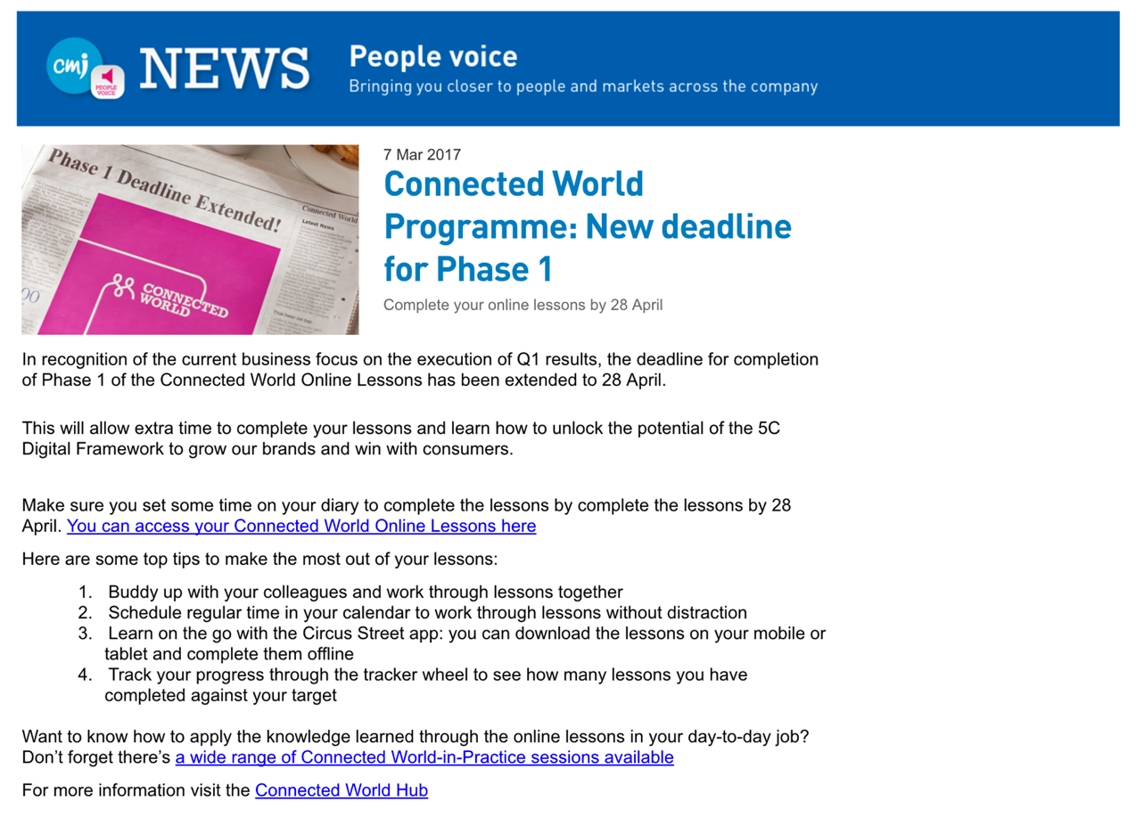

The numbered components are outlined below:

1. **Title.** An area that displays the logo, title and a brief description of the People Voice site. This is presented on each page and held in the page layout files.
2. **Page Image.** Pulled from the Page Image site column in the page content type. If no image is added a placeholder image can be added. An image rendition is used to maintain a consistent size and dimension. This image is also used for the rollup image in the news article listing components.
3. **Article Date.** A manually inputted date field that is pulled from the page content type.
4. **Title.** Pulled from the page content type Title site column.
5. **Strapline.** A single line of text pulled from the page content type Strapline site column.
6. **Body Content.** Editable by the content administrator via the Page Content site column where they are able to input full publishing HTML including hyperlinks, tables, images and embedded videos etc.

# Information Architecture

The following section provides detailed information on the information architecture for the site. This includes the following topics:

* Overall site structure
* Detail on the lists and libraries used as part of the solution
* Listings of required content types and site columns

## Site

The People Voice site and its contents will be entirely held in the existing People Voice site, which is a subsite held in the CMI site beneath the following location:

<https://unilever.sharepoint.com/sites/Marketing/CMI>

The lists and libraries outlined in the following sections will all be held in this subsite.

## Lists

The following section outlines the main lists that sit within this site.

|  |  |
| --- | --- |
| Name | Description |
| Consumer Index | Used to define and manage the items held in the *Consumer Index* section. |
| Banners | Used to define and manage the banner links held in the *More from People Voice* section on the Home page. |
| Unilever Links | Used to define and manage the links held in the *Unilever links & ads* section on the Home page. |

## Libraries

The following section outlines the main libraries that sit within this site.

|  |  |
| --- | --- |
| Name | Description |
| Pages | The Pages library, a feature of the Publishing Portal site collection, will hold all Publishing pages for the site, including the People Voice news articles. |
| Images | An Assets Library used to hold all the images used in the site. |

## Content Types

Content types enable administrators to organise, manage, and handle content in a consistent way across the sites. Defining content types for specific kinds of documents or information products ensures that each group of content is managed in a consistent way.

The following section outlines the main content types that will be created as part of this project.

|  |  |
| --- | --- |
| Name | Parent Type |
| Banners | Item |
| Unilever Links | Item |
| Consumer Index | Item |
| People Voice Article | Article Page |

**NOTE** This table does not outline the out-of-the-box Content Types that may be used as part of this project.

## Site Columns

A site column is a reusable column definition, or template, that can be assigned to multiple lists and libraries across SharePoint sites. Site columns are useful when establishing consistent settings across lists and libraries.

The following section outlines the main site columns that will be created as part of this project.

|  |  |  |
| --- | --- | --- |
| Name | Type | Comments |
| Title | Single line of Text |  |
| Order | Number |  |
| URL | Hyperlink |  |
| Image | Publishing Image |  |
| Consumer Index | Number |  |
| People Voice Category | Choice (Checkboxes) | People; Shopping; Media; Products |
| Spotlight | Yes/No | Defaults to No |

**NOTE** This table does not outline the out-of-the-box Site Columns that may be used as part of this project.

The following table maps the Site Columns to the Content Types they are used in.

* R = Required
* O = Optional

|  |  |  |  |  |
| --- | --- | --- | --- | --- |
|  | Banners | Unilever Links | Consumer Index | People Voice Article |
| Title | R | R | R | R |
| Order | O | O | O |  |
| URL | O | O | O |  |
| Image | R |  |  |  |
| Consumer Index |  |  | R |  |
| People Voice Category |  |  |  | R |
| Spotlight |  |  |  | O |

# Solution Assets

The following section outlines the custom solution assets (master page, CSS, JavaScript etc.) which have been created as part of the project requirement.

Where possible we opt for configuration over development and minimise customisation to any SharePoint functionality. By provisioning supplementary page layouts, and well documented JavaScript, HTML and CSS, we ensure as far as possible that our development is extendible, reusable and future-proofed against Office 365 updates.

To manage or amend the assets outlined in this section requires SharePoint development expertise, Front-End development expertise and expertise in the code and frameworks referenced in this section.

## Master pages

The global elements of the site will be contained in the master page. The master page is a feature that enables the ability to define common structure and interface the website, including headers, footers, style definitions, navigation bars etc. The master page will be shared by all of the pages in the site and removes need to duplicate shared elements.

The People Voice site will use the Inside Unilever master page. Golin will make no changes to the master page as part of this project.

## Page layouts

Page layouts in SharePoint are files which help to predefine the overall arrangement of elements (content) within a publishing page.

The following table outlines the custom page layouts required as part of the solution:

|  |  |
| --- | --- |
| Name | Content Type |
| People Voice Article | People Voice Article |

## CSS

The Style Library site will utilise CSS and CSS3 specifications to handle the presentation of the HTML and content such as setting the layout, fonts and colours.

The CSS will be created locally using the CSS pre-processor Sass and compiled down to standard CSS before being uploaded to the site. All CSS will be contained within a single file and is stored in Style Library.

## JavaScript

All JavaScript will be created locally using the module bundler webpack 1.14.0 (<https://webpack.github.io/>) to concatenate the files into a single minified JavaScript file. The JavaScript file will be stored in the Style Library.

## Frameworks and Libraries

The following JavaScript and CSS frameworks that are used within the solution:

|  |  |  |
| --- | --- | --- |
| Name | Description | URL |
| React | A JavaScript library for building user interfaces | <https://facebook.github.io/react/> |
| jQuery 3.1.1 | HTML document traversal and manipulation, event handling, animation, and Ajax | <https://jquery.org/license/> |
| PnP JS Core | Library to help simplifying common operations within SharePoint and the SharePoint Framework. | <https://github.com/SharePoint/PnP-JS-Core> |
| Moment.js | Full featured date library for parsing, validating, manipulating, and formatting dates. | <http://momentjs.com/> |
| Office UI Fabric | The official front-end framework for building experiences that fit seamlessly into Office and Office 365. | <http://dev.office.com/fabric> |

## Imagery

All imagery used as part of the solution will be optimised for the web and stored in the Style Library.

Golin will be providing the image assets necessary for the development of site design as per the approved wireframes and designs.

**NOTE** Beyond the imagery used within the approved designs, sourcing and licensing for additional imagery is excluded.

### Image renditions

An image rendition defines the dimensions that are used to display images in a SharePoint site. The following image renditions will be defined for this project:

|  |  |  |
| --- | --- | --- |
| Name | Width | Height |
| People Voice Article Image | TBC | TBC |

## Fonts

A number of custom web fonts will be used as part of the site design, as well as additional font files. All font files will be stored in the Style Library.

# Accessibility

SharePoint Online provides a number of accessibility features out-of-the-box which helps to ensure that the sites are accessible to people with disabilities as outlined in the following article:

<https://support.office.com/en-gb/article/Accessibility-features-in-SharePoint-products-f291404a-dc7e-44de-a31f-d81b3099c2b9>

Where possible we will ensure that the solution will remain in line with SharePoint’s own out-of-the-box Accessibility standards.

# Development

Development of the People Voice site will be completed on a SharePoint Publishing site. The site collection will be hosted on Unilever’s development tenancy and was provided to Golin by the Unilever Collaboration Service/SharePoint Delivery team.

## Code Control

During the development phase, the project will be held within a private Github.com repository. Git, which is a distributed revision control and source code management system, will be used by Golin to manage all development for the site.

As requested by the Unilever Collaboration Service/SharePoint Delivery team, during the development phase the code will periodically pushed to a People Voice site repository on Unilever’s Visual Studio Team Services (VSTS):

<https://cstfsunilever.visualstudio.com/Team%20Golin/>

# Browser & Device Testing

Where possible the site will be built in accordance with the Microsoft SharePoint browser support plans:

* <https://technet.microsoft.com/en-GB/library/cc263526.aspx>
* <https://products.office.com/en-us/office-system-requirements>

*“SharePoint 2013 supports several commonly used web browsers, such as Internet Explorer, Google Chrome, Mozilla Firefox and Apple Safari. However, certain web browsers could cause some SharePoint 2013 functionality to be downgraded, limited, or available only through alternative steps.”*

The site will be tested against the browsers and devices outlined in the following table:

|  |  |
| --- | --- |
| Browser | Device |
| Internet Explorer 11+ | Desktop/laptop |
| Chrome (latest version) | Desktop/laptop |
| Safari (latest version) | iPad, iPhone 6+ |

# Deployment

Following completion of the development phase and after Golin’s internal testing phase, the solution, which includes all assets, configurations, lists, libraries, content types etc. will need to be deployed to the following site collections:

* Dev Int: TBC
* QA: TBC
* Production: TBC

All site collections have been pre-setup by the Unilever Collaboration Service/SharePoint Delivery team.

To facilitate moving the solution between these site collections, deployment and configuration of assets and features will be handled by scripts created in Microsoft PowerShell, an automation and scripting platform for Windows built on top of the object-oriented power of the .NET Framework.

The deployments to Dev Int, QA and Production will be completed by the Unilever Collaboration Service/SharePoint Delivery team, therefore Golin will provide a brief deployment guide, that outlines the required deployment steps and manual configurations.

# Training

As part of the of the delivery of the project and upon completion of the development of the site, Golin will orchestrate a single two-hour Site Administrators training session.

As Unilever will have been given visibility during the development phase, it is anticipated that the training agenda, supplemented by the supporting handover documentation, will focus only on the key tasks for the administration of the site.

# Documentation

Golin will supply an updated version of this document outlining all the customisations and configurations made as part of the site development. As mentioned in the section on Deployment, this document will include a brief deployment guide, that outlines the required deployment steps and manual configurations.

**NOTE** All documentation will assume administrator knowledge of SharePoint and Office 365.